PLC Control Information

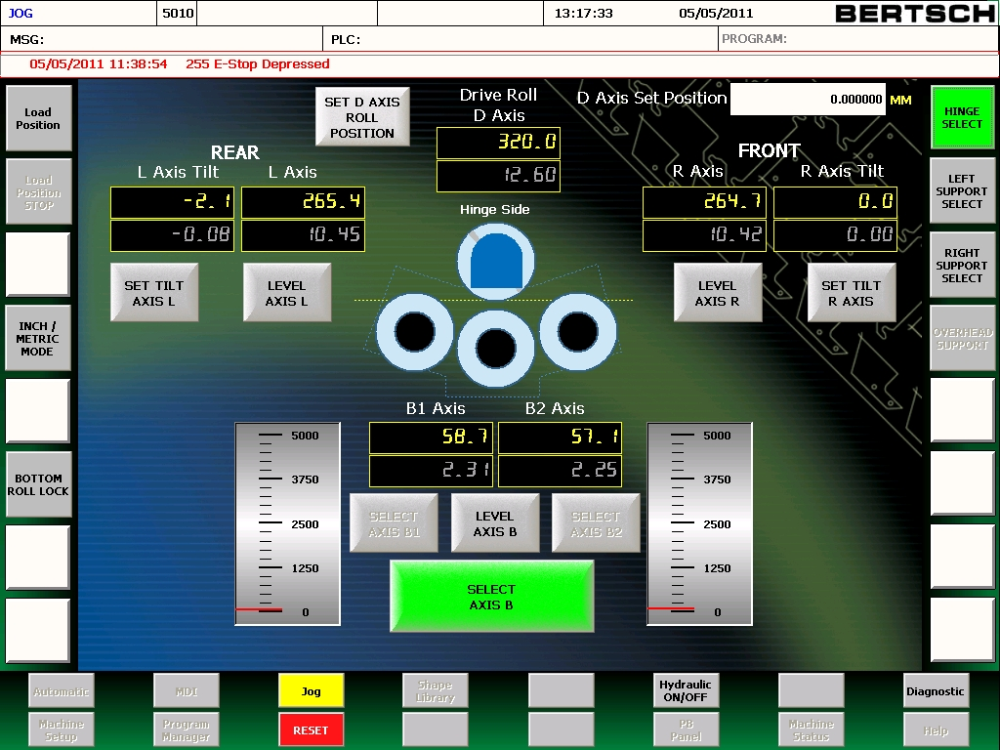


800-338-5471

Introduction

The following information is designed to give you information on the PLC Control. This control has been developed as a new axis leveling system as well as an upgradable control to further advanced control functions. You will notice options and features that appear grayed out. Any axis or features that appear grayed out are inactive and cannot be used at this level of control.

Log In/Password

Log In information for this control is as followed:
Username: guest
Password:
(No Password)

Table of Contents

Introduction 2
Log In/Password 2
Table of Contents 3
The Jog Screen Layout 5
Hinge/Auxiliary Joystick Functions 7
Roll Axis Position Displays 8
Roll Tilting Function/Displays 9
Removing the Tilt and Re-leveling Rolls 10
Pinch Pressure Gauges 11
D Axis Set Position 12
Teach / Edit Screen 13
Programming 15
Auto Screen 18
Program Manager 19
Diagnostic Screen 20
Service Log In Screen 21
Machine Setup Screen 22
Network Setup Screen 23

The Jog Screen Layout
Date and Time

Model

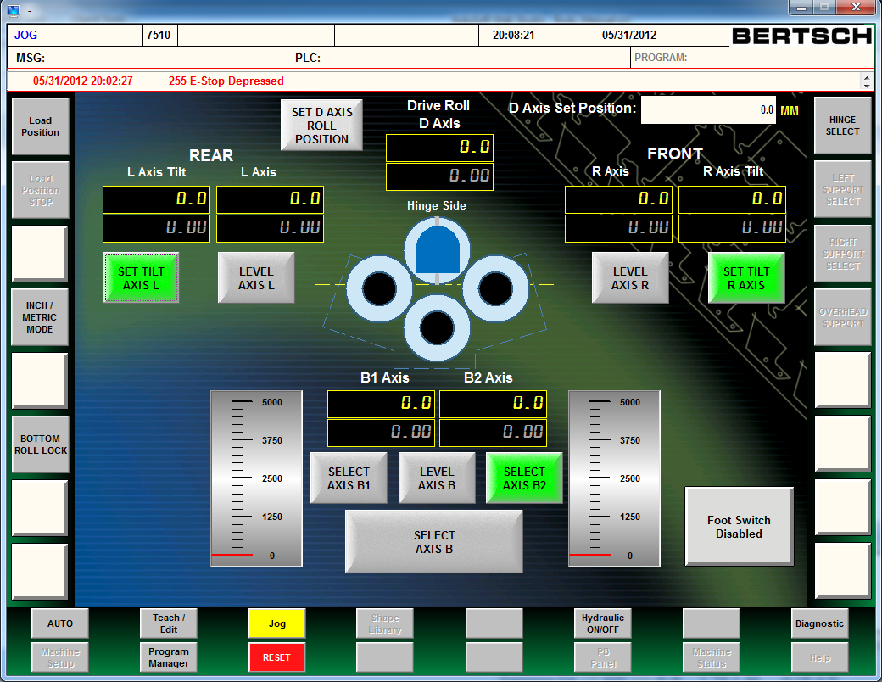
1
4
3
2
- Load Position- Moves one side roll up to square the material against, the other side roll and bottom roll down to a level position to feed the plate into the machine.
- Load Position Stop- Stops automatic roll positioning while axis are moving into the load position
- Inch/Metric Mode- This highlights the inch or mm displays and changes the D Axis Set Position to inch or mm.
- Bottom Roll Lock- Activates a blocking valve which shuts off flow to the bottom roll hydraulic motor. Assists the operator when rounding a cylinder without pinching the top and bottom rolls together. This feature is only active when the bottom roll is lowered to a safe position near the bottom of stroke.
9,100001
7,86
5,6
12
11

- Auto- Changes the control mode to Auto and displays the Auto screen
- Machine Setup- Displays the Machine Setup screen
- Teach / Edit- Changed the control mode to Edit and displays the Teach / Edit screen
- Program Manager-Displays the Program Manager screen
- Jog- Changes the control mode to Jog and displays the Jog screen
- Reset- After E-Stops or Alarms are set back to operating condition, this button must be selected
- Hydraulic ON/OFF- Engages or Disengages the electric motor starter
- Diagnostic- Displays E-Stops and Error Messages
13
17
16
15
14

Hinge/Auxiliary Joystick Functions

- Hinge Select- Hinge/Aux Joystick now operates the Hinge Open and Closed
- Left Support Select- Hinge/Aux Joystick now operates the Left Support Up and Down
- Right Support Select- Hinge/Aux Joystick now operates the Right Support Up and Down
- Overhead Support- Hinge/Aux Joystick now operates the Overhead Support Up and Down
- Foot Switch- Enables / Disables foot switch for jogging the drive rolls

Roll Axis Position Displays
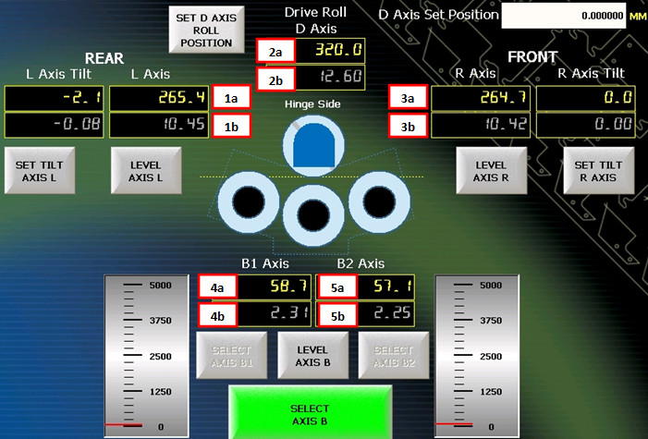
- L-Axis/Left/Rear Roll Position Indicators
  - Displays distance from top roll in millimeters
  - Displays distance from top roll in inches
- D Axis/Rotation Distance Indicators
  - Displays rotation distance since last set position in millimeters
  - Displays rotation distance since last set position in inches
- R-Axis/Right/Front Roll Position Indicators
  - Displays distance from top roll in millimeters
  - Displays distance from top roll in inches
- B1-Axis/Bottom Roll Hinge End Position Indicators
  - Displays distance from top roll in millimeters
  - Displays distance from top roll in inches
- B2-Axis/Bottom Roll Gear End Position Indicators
  - Displays distance from top roll in millimeters
  - Displays distance from top roll in inches

Roll Tilting Function/Displays
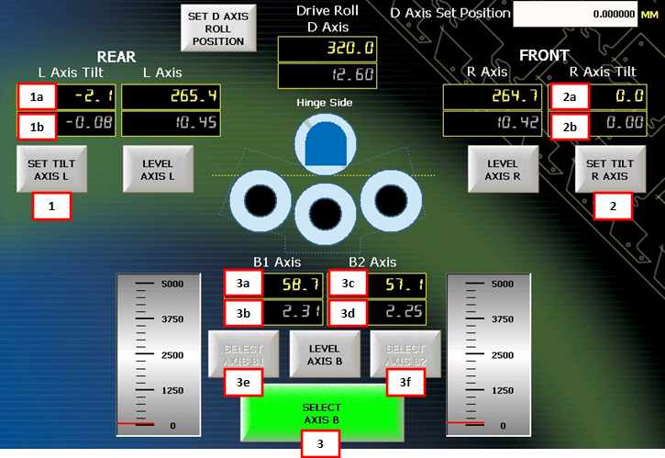
1 or 2 Select the “Set Tilt Axis L/R” button and the two ends of the rolls become uncoupled. Movement of the L or R Axis joysticks will only move the hinge end of the roll to induce a tilt. This tilt is limited to approx. ¼” per foot of roll width. De-selecting this button re-couples the ends of the rolls and will move both ends simultaneously in the induced tilt.
1a or 2a Displays distance of tilt in millimeters
1b or 2b Displays distance of tilt in inches
- Select Axis B button couples and uncouples the B axis cylinders
3a and 3c Displays actual position in millimeters for hinge and gear end
3b and 3d Displays actual position in inches for hinge and gear end
When you uncouple the B axis cylinders by de-selecting the “Select Axis B” button you will be able to choose axis B1 or B2 by selecting the 3e or 3f button. The B-axis joystick will then only move the selected end until you re-couple the cylinders by selecting the “Select Axis B” button labeled button 3.

Removing the Tilt and Re-leveling Rolls
3
2
1

1 and 2 The Level Axis L and R Buttons when selected remove the tilt and automatically raises or lowers the hinge end to achieve a level position. This will achieve a very close to level position; the first jog of that axis will finish level the axis. If the Level Axis L or R button is pressed a second time while in motion, it will stop movement.
3 Currently the Level Axis B Button must be pressed 3 times to level automatically. Selecting this button again in motion will stop movement.

Pinch Pressure Gauges

The two gauges circled above give the operator a live view of the pinch pressure as you are clamping the plate to the top roll. It is always best to pinch the material with just enough pressure to keep the rolls from slipping on the plate. If there is a need to adjust one side or the other you can use the B-axis tilting feature described on the previous page to adjust one side or the other.
It is normal to see this pressure increase while rolling, especially during the pre-bending of the sheet. The material acts as a lever and the pressures will rise in the cylinders.
Also, be aware that sometimes when multi-passing material, thinning can occur in the plate causing you to lose pinch pressure. If you see your pinch pressure drop to zero, bump up your B-axis until you achieve your desired pressure.

D Axis Set Position

The Set D Axis Roll Position button resets the D Axis Readout to whatever dimension has been input into the D Axis Set Position Input Box at the top right hand corner of the screen. The Inch/Metric Mode Key described on page 4 of this manual toggles this dimension from inches to mm. The data input into this box does not convert from inches to metric automatically. It will assume that a 25 in the data box is either 25 inches or 25 mm as you change to metric mode.
This feature may prove useful when rolling parts with flat ends or to go back to the same part of the plate to add more of a radius.

The Teach / Edit Screen Layout
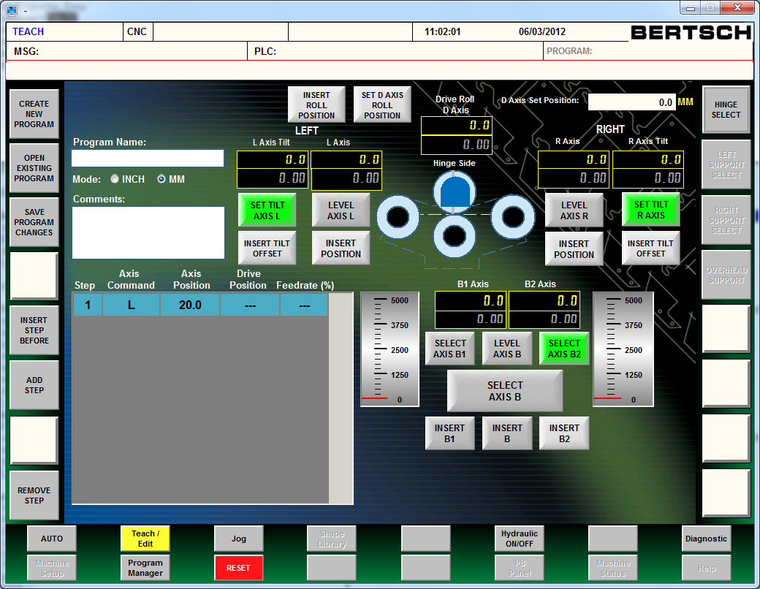
13
12
15
14
16
17
18
11
10
9
7
8
3
6
5
4
1
2
- Create New Program- Creates new program
- Open Existing Program- Opens a program for editing
- Save program Changes- Saves the current program to the controller
- Insert Step Before- Inserts a new program step before the highlighted step
- Add Step- Adds a program step at the end of the program
- Remove Step- Removes the highlighted step from the program
- Program Name- Displays the name of the active program
- Mode- This highlights the inch or mm displays and changes programming mode to inch or mm.
- Comments- Displays comments for the active program
- Program Steps- Displays all the program steps
- Insert Roll Position- Inserts drive roll command(D) and current drive roll position into the highlighted program step
- Insert Position(Left)- Inserts move left roll command(L) and current left roll position into the highlighted program step
- Insert Tilt Offset(Left)- Inserts tilt left roll command(TL) and current left tilt offset into the highlighted program step
- Insert Position(Right)- Inserts move right roll command(R) and current right roll position into the highlighted program step
- Insert Tilt Offset(Right)- Inserts tilt right roll command(TR) and current right tilt offset into the highlighted program step
- Insert B- Inserts move bottom roll command(B) and current bottom roll position into the highlighted program step
- Insert B1- Inserts move bottom 1 roll command(B1) and current bottom 1 roll position into the highlighted program step
- Insert B2- Inserts move bottom 2 roll command(B2) and current bottom 2 roll position into the highlighted program step
Programming
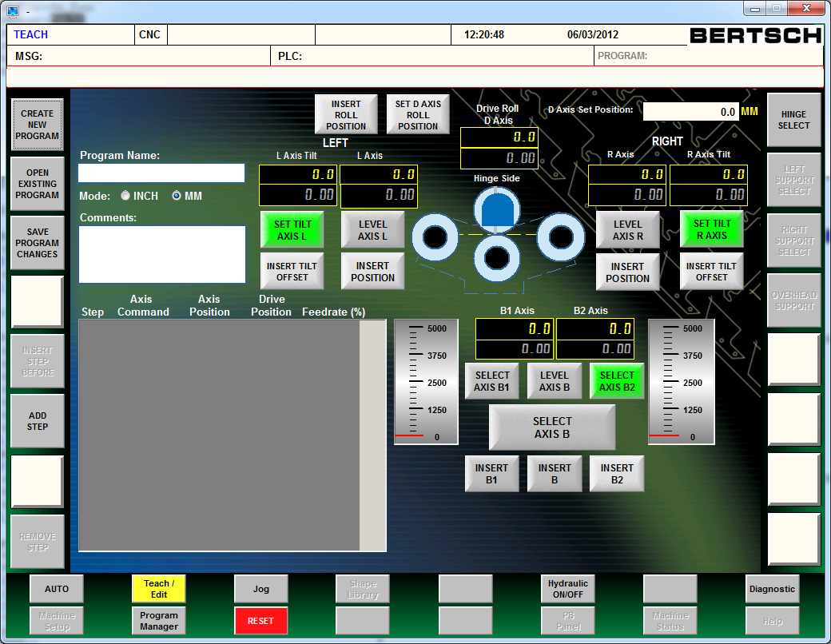
7
6
4
5
3
2
1
Creating a new program.
- Click the Create New Program button
- Click in the Program Name textbox. Use the screen keyboard to enter the name of the program.
- Select programming units, inch or mm.
- Click in the Comments textbox to add program comments.
Adding and removing program steps
- Click Add Step to add a program step and the end of the program
- Click Insert Step Before to insert a program step before the highlighted step
- Click Remove Step to remove the highlighted program step
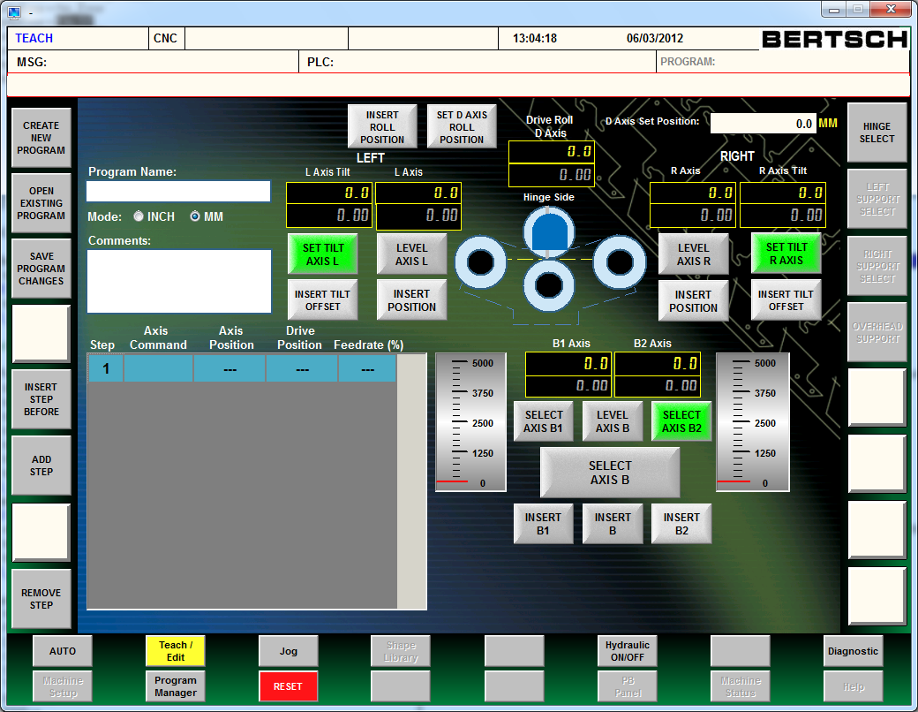
Adding roll commands to a step
4
3
2
1
- Click on a step to select it. The step will be highlighted when selected.
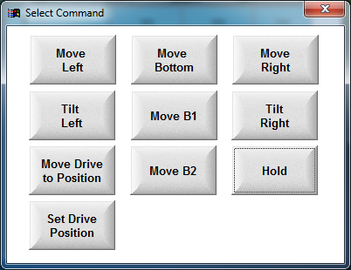
- Click on any of the Insert buttons to insert an roll command and position, or click on the Axis Command box in the highlighted step to display a list of roll commands
a
b
c
d
e
f
g
h
i
j
  - Move Left (L)- Inserts command to move the left roll.
  - Move Bottom (B)- Inserts command to move the bottom roll.
  - Move Right (R)- Inserts command to move the right roll
  - Tilt Left (TL)- Inserts command to tilt the left roll
  - Move B1 (B1)- Inserts command to move the drive end of the bottom roll
  - Tilt Right (TR)- Inserts command to tilt the right roll
  - Move Drive to Position (D)- Inserts command to move the drive rolls.
  - Move B2 (B2)- Inserts command to move the hinge end of the bottom roll
  - Hold (HLD)- Inserts command to pause execution of the program
  - Set Drive Position (DS)- Inserts command to change the drive roll position
- Click on the Axis Position or Drive Position box in the highlighted step to change the position value
- Click on the Feedrate(%) box in the highlighted step to adjust the moving speed of the rolls.

The Auto Screen Layout
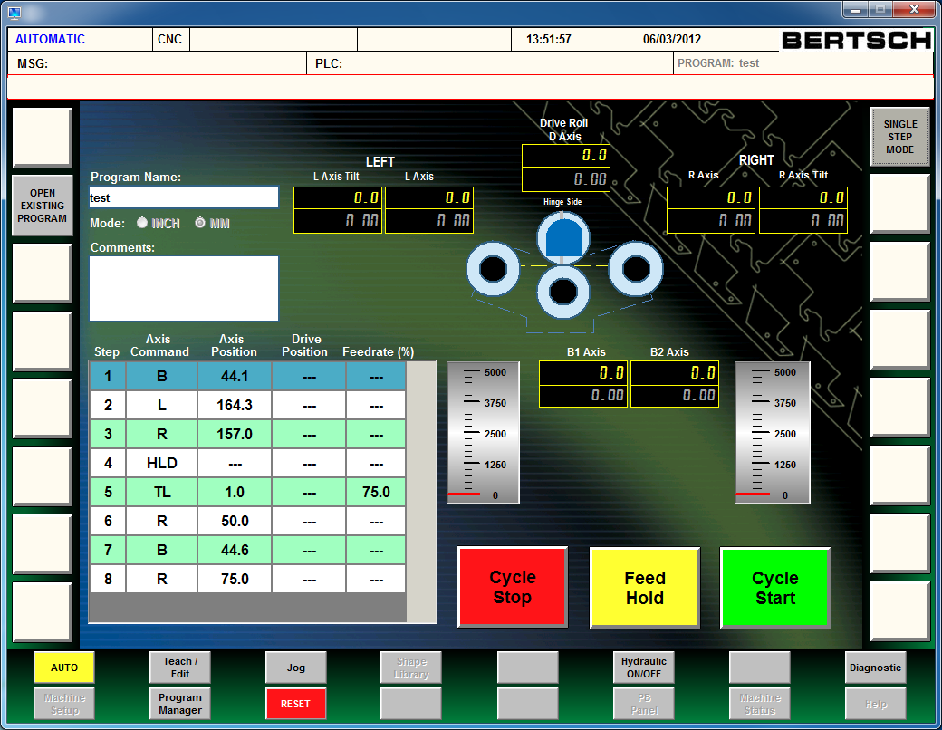
9
8
7
6
5
4
3
2
1
- Program Name- Displays the name of the active program
- Mode- This highlights the inch or mm
- Comments- Displays comments for the active program
- Program Steps- Displays all the program steps
- Cycle Stop- Press to stop execution of the program
- Feed Hold- Press to pause execution of the program. Once the program is paused, press again to continue. Press to continue after a program hold step or when running in Single Step Mode
- Cyle Start- Press to start the execution on the current program
- Open Existing Program- Opens a program to run
- Single Step Mode- Pauses program execution after each program step. Press Feed Hold(6) to continue.
The Program Manager Screen Layout
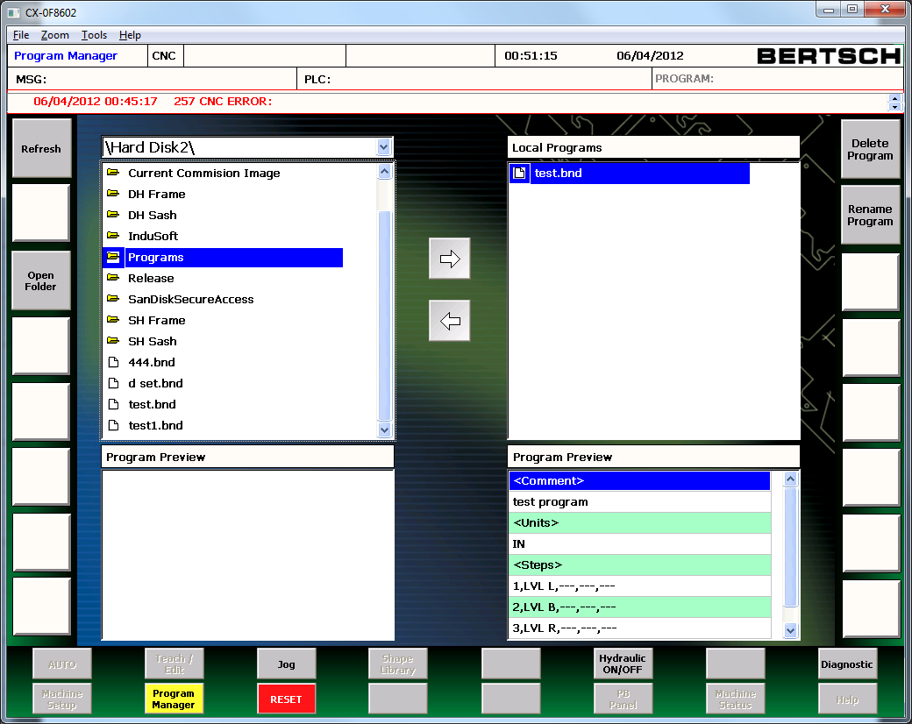
10
11
7
6
4
5
3
9
8
2
1
- Refresh- Reloads the drive list (3)
- Open Folder- Opens the selected folder
- External drive list- Displays all the connected external drives(USB & Shared network folders)
- External Program List- Displays all the external folders and programs
- External Program Preview- Displays the selected program
- Local Program List- Displays all the programs on the machine controller
- Local Program Preview- Displays the selected program
- Delete Program- Deletes the selected program from the machine controller
- Rename Program- Renames the selected program on the machine controller
- Move to External Drive- Moves the selected program on the machine controller to the selected external drive
- Move to Machine- Moves the selected program on the external drive to the machine controller
Diagnostic Screen
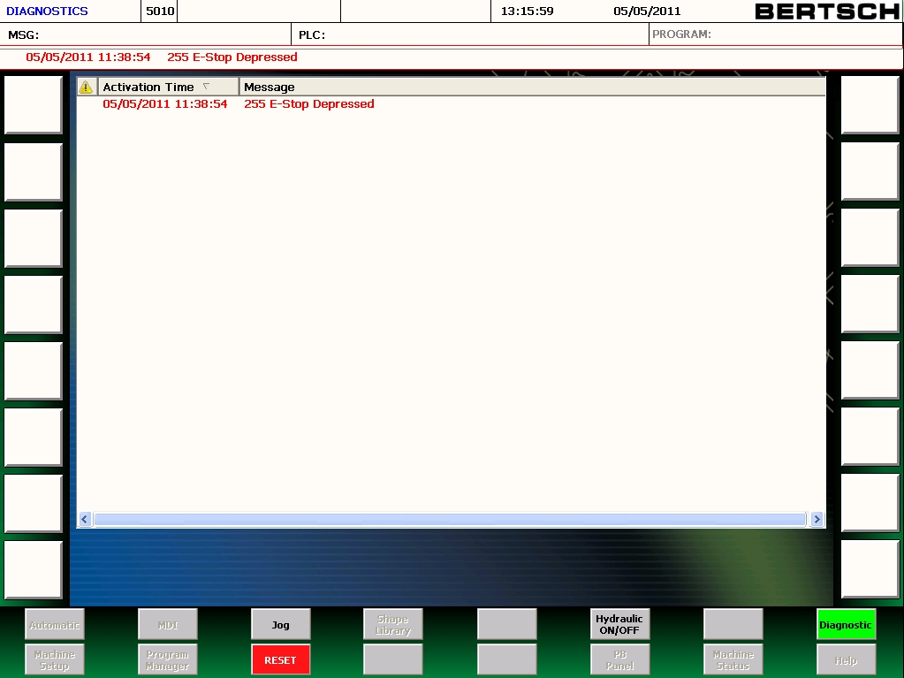

The diagnostic screen lists the current alarms and messages and their activation time. After the E-stop or limit switch position has been made to allow the machine to operate, you must depress the Reset button to clear the alarm or message.

Service Log In Screen
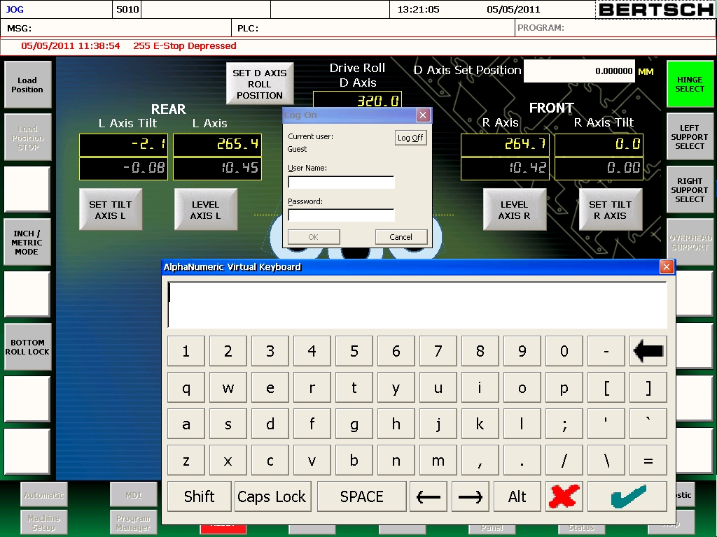

To access the service log in screen you must select the logo at the top right hand corner of the display. The user name and password must be supplied by our service department when needed. When the user name and password have been entered and the hydraulics are turned off, you will be able to select the Machine Setup button on the bottom left hand corner of the display.

Logging off of this mode will automatically set you back to guest log in status and you will be able to access all of the machines standard functions.

Machine Setup Screen
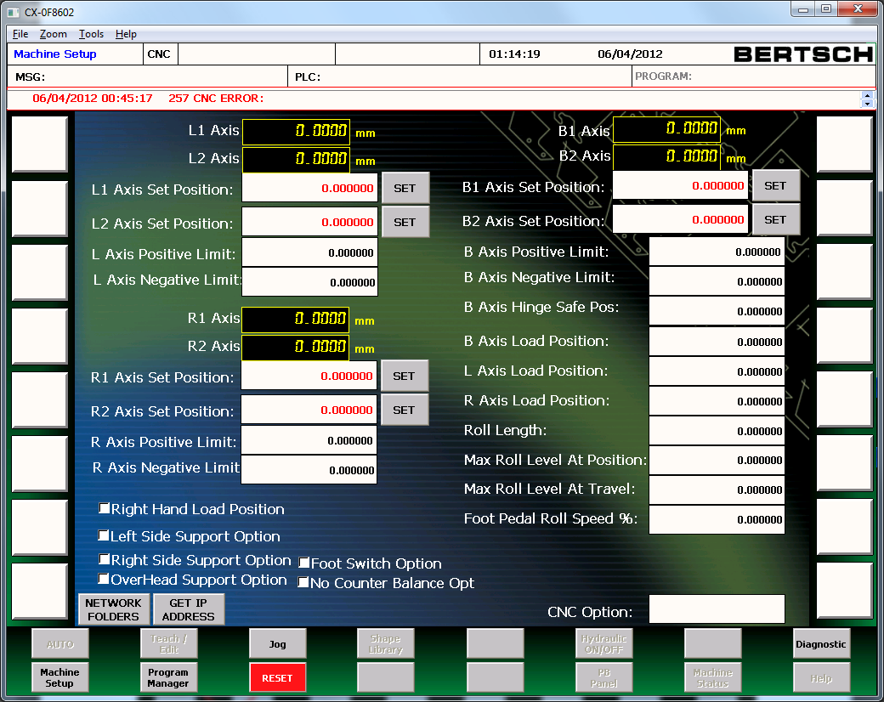

This screen holds the data points for all encoder calibrations, position limits, optional supports and also the defaults for the load positions for the rolls.
The get IP address button will identify the IP address for you when connected to a network. This will help in connecting to our Service Department remotely.
The network folders will the network setup screen

Network Setup Screen
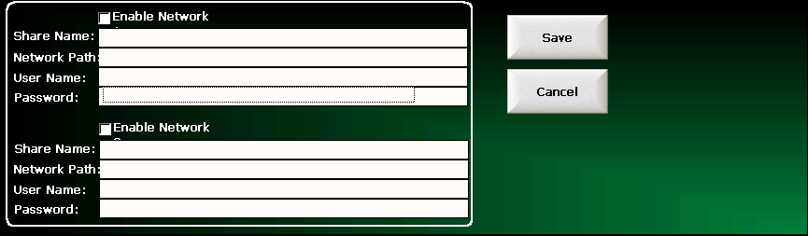
- Enable Network- Enables network connection
- Share Name- Name of shared folder to be displayed in the file manager
- Network Path- The full network path of the shared folder
- User Name- Windows user name
- Password- Password for Windows user
Notes:
- Two network connection can be active
- Share name cannot contain spaces
- If you are connecting to Windows Vista, Windows 7 or Windows 2008 Server, you must make sure to adapt the security policy on these systems. By default, Windows Vista, Windows 7 and Windows 2008 Server are configured to only accept version 2 of the NTLM protocol for network communications. Because Windows CE uses NTLM version 0.12, access will fail. As a workaround, you can configure Windows to also accept older versions of NTLM:
  - Open the "Start Menu" and go to the "Control Panel"
  - Open "Administrative Tools" and start the "Local Security Policy"
  - Navigate to "Local Policies\Security Options"
  - Double-click on the entry "Network Security: LAN Manager authentication level" and select "Send LM & NTLM responses" in the dropdown box
  - Restart your system
Contact your Windows System Administrator for assistance.

