Sharp Precision Machine Tools
PROPOSAL
___________

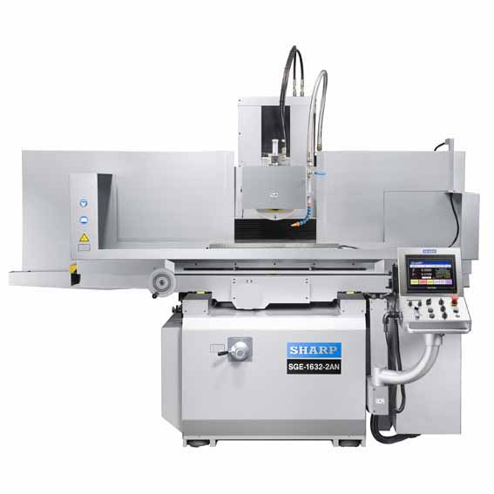
Photo shown as SG 1632-2AN ___

Automatic Surface Grinder

SGE-1640-2AN

Sharp SGE-1640-2AN $ 81,250.00
Hydraulic Grinder

STANDARD EQUIPMENT:

- Grinding Wheel 12” x 2” x 5”
- Downfeed is driven by servo and ball screw
- High precision linear guide ways on vertical slide ways
- Cress feed is driven by servo and ball screw
- Precision Hydraulic Table
- Auto Lube System
- Wheel Adapter/Flange
- Wheel Balancing Arbor
- Diamond Dresser
- Splash guard both front and back ( not shown on photo)
- Dust sweeping plate
- Working lamp
- Leveling plates, bolts and nuts
- Eyebolt
- T-nut and screws
- Lubrication oil, 16 liters ( Mobil # 1405)
- Tool Kit includes:
Machine Manual, Wrench 36 mm, adjustable wrench, Phillip screw driver, hexagon-headed spanner ( 2.5, 3, 4. 5. 6. 8 mm), spare can of paint,.

FEATURES:

- Programmable Spindle Downfeed and Cross Feed System with User Friendly Interface)
- 5HP Motor
- Spindle Speed 1,755 rpm
- 2-V Ways
- Extra Wide Bed
- Double Longitudinal “V” Ways and Cross “V” Ways
- Hydraulic Table (with Over Travel Protection)
- Slide Ways are Hand Scraped and Turcite Coated
- Annealed Castings for Greater Machine Stability
- 440 V application needs an optional transformer

SPECIFICATIONS:
- Capacity
- Table Travel 18” x 43”
- Spindle Center to Table Surface 27.6”

- Table
- Working Surface (W x L) 15.7” x 39.4”
- Longitudinal Hydraulic Table Feed 98.4 IPM
- Maximum Longitudial Travel 44.1”
- Max cross feed 18.1”
- T-slot ( No. x width) 3 x 0.67”

- Cross Feed
- Feed rate range 0.5 – 10 ipm
- Auto feed range 0.0001” – 0.4”
- Rapid traverse feed rate 10 ipm
- Resolution of MPG ( electronic handweel) 0.0001”

- Vertical Travel
- Feed rate range 0.5 – 10 ipm
- Auto feed range 0.0001” – 0.4”
- Rapid traverse feed rate 10 ipm
- Resolution of MPG ( electronic handweel) 0.0001”
- Spark out 0-9 times
- Wheel Size (OD x Width x ID) 12” x2”x5”
- Spindle Motor 5 HP/ 4P
- Spindle speed 1455 IPM
- Coolant System Motor
- Approximate Weight 9240 Lbs.
- Hydraulic pump 5 HP
- Cross feed motor 1 HP
- Vertical feed ( AC servo) 0.5 HP
- Floor space 134”x110”x83”
- Packing dimensions 129”x91”x94”

- Total Power Consumptions
- 220V 38A
- 440V 22A

OPTIONAL ACCESSORIES:

16” x 40” Kanetsu Permanent Chuck with sine plate $ 2160.00
16”x 40” Kanetsu Electro-magnetic chuck $ 5140.00
16” x 32” Kanetsu Electromagnetic Chuck (Fine Pole) $ 7750.00

***All Magnetic Chucks Includes FREE Installation***
440 V transformer $ 3000.00

Halogen Work light WL-110V55W $ 204.75

Grinding wheel balancing apparatus ( MCL-230) $ 620.00

Spare grinding wheel adaptor $ 500.00

Dust suction system $
Inverter ( 7.5HP) ( AC motor speed commander) $ 1480.00

Micro feeder for cross movement $ 1330.00

Punch former $ 1700.00

Consistent temperature control for hydraulic $ 3390.00

Coolant System w/ magnetic dust separator $ 2040.00

Coolant System w/paper filter & magnetic dust separator $ 3100.00

Coolant System w/ paper filter $ 2250.00

Coolant system $ 1050.00

Radius dresser device $ 300.00

Angle dresser device $ 300.00

Sine vise $ 680.00

Tool maker vise $ 900.00

Table stop to right $ 1040.00

Hydraulic dresser mounted on the wheel head $ 1890.00

Automatic demagnetizing controller $ 760.00

Manual dresser mounted on the wheel head $ 810.00

Dynamic balancer for grinding wheel $ 3630.00

Power conditioning tools for diamond & CBN wheel $ 2940.00

***All Prices and Specifications Subject to Change without Notice.
30 % deposit is required and payment terms subject to Sharp standard terms and conditions.

