Table Of Contents

FG3015T
(5’ x 10’)

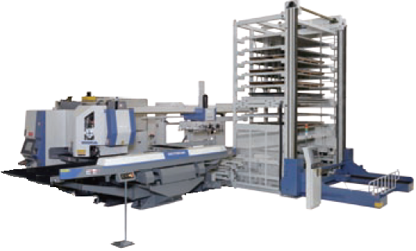

Automatic Loader/Unloader
Pick and Sort System
Specification

Murata Machinery USA, Inc.
Machine Tool Division
2120 Queen City Drive
Charlotte, North Carolina 28208
(704) 875-9280

1 General Description 3
2 Device Descriptions 4
2.1 Turret Punch Press 4
2.2 Tower System 4
2.3 Servo Controlled Loader/Unloader 4
2.4 Material Pallet 5
2.5 Finished Parts Pallet 5
2.6 Additional Finished Parts Tables (optional) 5
2.7 Skeleton Box 5
2.8 HIFLEX-7 Controller 6
3 Material Specifications 7
3.1 Individual Sheets 7
3.2 Stacks of Sheets 7
3.3 Finished Part Unloading Specifications 8
4 Details Of System Specifications 9
4.1 Raw Material Setup 9
4.2 Parting Position Of The Nested Part 9
4.3 Part Shape 9
4.4 Loader Vacuum Pads 9
4.5 Part Stacking 10
4.6 Part Lifting Position 10
4.7 Skeleton Unloading 10
5 System Operation 11
5.1 Standard Operation 11
5.2 Halting Automatic Operation 12
5.3 Automatic Shutoff 12
5.4 Turret Standalone Operation 12
6 Pre-Installation Requirements 13
6.1 Safety 13
6.2 Foundation 13
6.3 Utilities (Electric and Pneumatic) 13
7 Layout Drawing 15

General Description

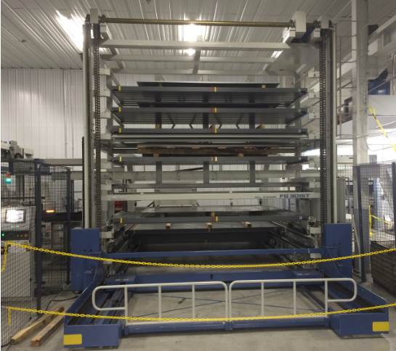
The FG Tower automation is a standard system for the Murata Turret Punch Presses. The additional sub-head and brush table tops must be included with the machine when ordering this system. The FG3015T provides fully automatic loading and unloading of material to the turret punch press. As parts are punched, nested parts can be completely separated, unloaded, and sorted onto finished parts pallets. The remnant remaining is then unloaded to the Skeleton pallet. Cut to size parts can also be processed in this system without any nesting requirements. A six or eight drawer stocker allows storing of raw material and finished parts. Optionally, multiple Skeleton pallets can also be stored in the stocker for longer unattended operation.

All the automation operates from the right side of the system. The loader uses pneumatic vacuum pads to load blank sheets on the press. Finished parts are unloaded using the same vacuum pads. The skeleton is removed using mechanical grippers. All pallets are loaded and unloaded from the front of the system at the stocker elevator.

The interaction of these devices is coordinated by the Hiflex Controller, using the following:
- Part Programs The NC program has all punching codes for the nested parts. Additional codes are also generated by the software nesting system for controlling the pickup and unloading of parts.

- Production The operator enters schedule data identifying production
Schedule quantities, the program to be used and material data controlling the automated load/unload process.

Estimated Loader Cycle Time:
- Sheet Loading 75 seconds
- Part Picking 10 seconds
This is the average estimated cycle time for parts to be removed from the press table and punching can continue. Larger parts and vacuum pad repositioning can increase this time.
- Average Pallet
Exchange Time 120 seconds

Device Descriptions

Turret Punch Press
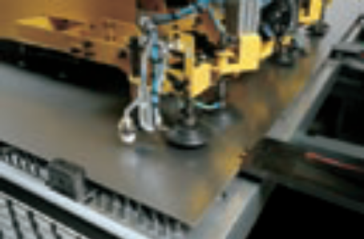
The automation interface includes touch switches on the workholders and an auto-endlocator. Parts are separated from the skeleton using a sub-head punch mounted outside the turret or using a standard punch in the turret. The required brush table helps parts lay flat and eliminates chances of vacuum pads gripping the table top when unloading parts.

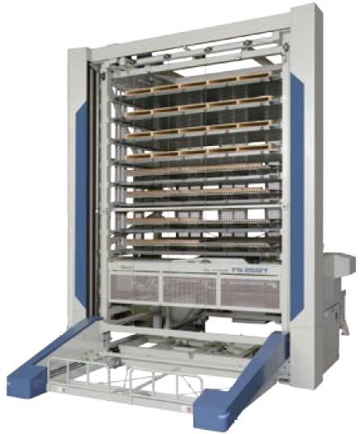
Tower System
This system provides automated storage/retrieval of material, product and skeleton pallets. An integrated Mitsubishi PLC controls the operation of the stocker during manual and automatic operations. The number of drawers (6 or 8) is selected at time of purchase. Each drawer contains a steel pallet. A wooden pallet is placed on this. The elevator on the front of the system is used for introducing pallets into the system, removing pallets from the system, and exchanging pallets within the system.

Servo Controlled Loader/Unloader
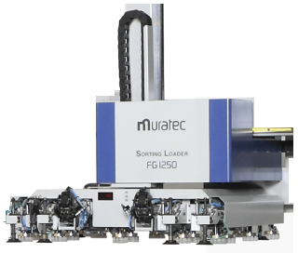
Transfers blank sheets from the Material Pallet using automatically activated vacuum pads and positions the sheets on the Turret Punch Press. Sheet separation is accomplished with magnet floaters, air blow, and vacuum pad shaking / tilting action. A double sheet detector device verifies that only one sheet is picked up. After processing, finished parts are picked up and sorted using the same vacuum pads. Unload grippers mounted on the unit are used to remove the skeleton after all parts have been removed from it.

Positioning Repeatability: .0039 in. (0.1mm)

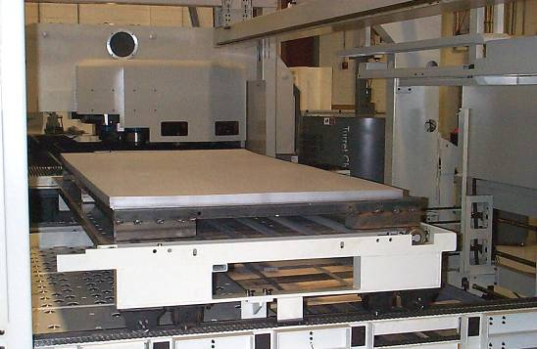
Material Pallet
This pallet contains a stack of raw material. The stocker elevator will retrieve the requested drawer and transport it to the base of the unit. The pallet is then transferred to the back of the stocker unit where the loader can access it. The material is loaded to the front of the pallet against positioning bars. The loader will scan to the edge of the material to determine exact positioning.

Finished Parts Pallet
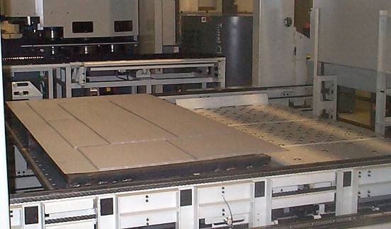
This pallet contains a stack or stacks of finished parts. The stocker elevator will retrieve the requested drawer and transport it to the base of the unit. The pallet is then transferred to the back of the stocker unit where the unloader can access it.

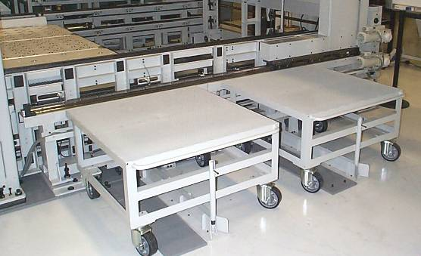
Additional Finished Parts Tables (optional)
Two additional stations are located at the right-most end of the system. Parts can be unloaded at these locations and bypass the standard Finished Parts Pallet. When operation stops, these tables allow immediate access to the parts.

Skeleton Box
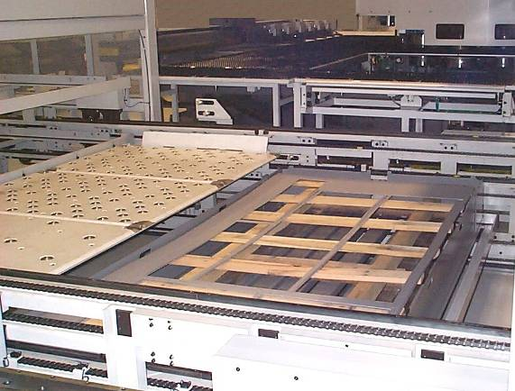
The remnant from the punching process is unloaded here. Grippers under the loader unit flip down, grip the edge of the sheet, and drag it off the press table. The standard system includes one of these boxes. When full or ready to unload, it is transferred to the front of the system, on the elevator, where it is accessed. Optionally, multiple skeleton boxes can be used. But, each one would be required to be stored in the stocker in a dedicated location. The requirement for additional skeleton boxes must be determined when the system is ordered.

HIFLEX-7 Controller
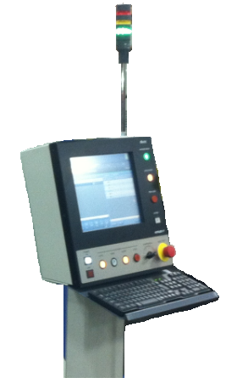
This system controller interfaces with the turret punch press and loader control system. It is used for operating the FG system equipment manually and automatically.

System Interface/Integration
The Hiflex has been integrated to all components of the system to control automatic system operation.

Manual Operations
The touch screen user interface allows manual movement and activation of all components in the FG system. All loader axes can be jogged and most solenoid activated devices can be controlled.

Loader Diagnostics
The user interface provided by the Hiflex provides diagnostic capabilities for use during system operation and for trouble shooting. All components have Hand screens that allow manual activation and sensor feedback through the use of LED type readouts.

Material Specifications

Individual Sheets
Types: Ferrous / Non-Ferrous

Sizes: Min. 11.8"(Y) x 29.5"(X) (300mm x 750mm) *full sheet load/unload
Min. 33.5"(Y) x 59.0"(X) (850mm x 1500mm) *for skeleton unload
Max. 60.0"(Y) x 120.0"(X) (1525mm 3050mm)

Thickness: Min. 0.024" (0.6mm)
Max. 0.177" (4.5mm)

Weight: Max. 375 lbs. (170 kgs)

Warping: Upper = 0.236" (6mm), including sheet thickness
Lower = Not allowed
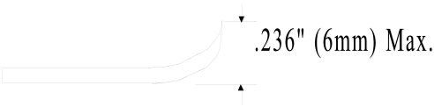

Stacks of Sheets
Total Height:
H(maximum height) = A(height of material) + B(height of pallet)
H = 5.7" (145mm) + 3.5” (90mm)
Minimum Pallet Height
H = 9.2" (235mm)
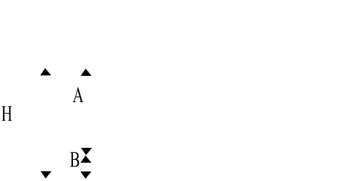

Maximum Stack Weight: 2.2 tons (2.0 metric tons)
*Note: with 5x10 steel, max mtl height is ~2.1”

Material Pallet:
- Blank sheets must be stacked on a wooden pallet and positioned using the locating pins provided on the traverser.
- Parallelism of stacked sheets must be within ±0.394 (10mm).
- No pre-punched holes or forming operations are allowed where vacuum pads hold the material.
- Excess oil may affect ability to pickup, separate, and load material.
- Good quality material and material stacks are critical to successful operation with automated load/unload equipment.

Finished Parts Pallet:
- Completed sheets with louvers or other forming such as tabs may be damaged when stacked; pre-testing and small stack heights are recommended.

Finished Part Unloading Specifications

The following are the nested parts size (X x Y) specifications for parts unloading. Unloading of full cut-to-size parts will match the loaded sheet size.

Parts separation using the sub-head punch:
Min. Size: 4.0 in. (100mm) x 4.0 in.(100mm)
Max. Size: 59.0 in.(1500mm) x 60.0 in.(1525mm)

Parts separation using standard punch:
Min. Size: 59.0 in.(1500mm) x 49.2 in.(1250mm)
Max. Size: 120.0 in.(3050mm) x 60.0 in.(1525mm)

Details Of System Specifications

Raw Material Setup

A pallet of blank material is positioned toward the center X position, Y=0 pin locations on the Material Pallet. The loader will automatically scan to find the edge of the top sheet of material using a photo sensor. The stack must be within 0.4" (10mm) of the Y=0 direction and left of center in the X direction.

Parting Position Of The Nested Part

If the length (X dim) of the part is more than 8.7” (220mm) and the sub-head is used to separate the part from the sheet, the parting position should be at a distance of 2/3 length of part from the bottom right side corner. If the part length is shorter than 8.7” (220mm) the parting position should be at the bottom left side corner.

If a standard punch is used to separate the part, the parting position should be at the bottom left side corner.

Part Shape

With parts other than rectangular shaped, you may observe some difficulty for picking or part transfer. Some testing may be required to determine effective operation with these type parts.

More consistent part unloading will occur if the length of the part (X dimension) is larger than the part width (Y dimension).

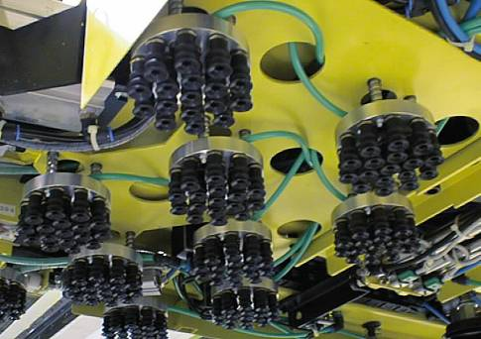
Loader Vacuum Pads

Holes larger than 3.1” (80mm) are not allowed under the vacuum pads.

Small size holes are allowed under the multi-pads, however depending upon the holes, the suction force will be affected. This may cause some difficulty during part pick-up.

Vacuum pads should not be positioned over the edge of parts. This could allow the vacuum pads to grip the remnant as well as the part.

A vacuum pad with the size diameter of 3.1” (80mm) has part suction capacity of 24lbs. (11Kgs).

It is mandatory to use at least 5 suction pads from the 17 Multi-pad system. In general, this will give the vacuum pad enough gripping power to assist in picking up the part.

Part Stacking

The maximum height of one part stack should be lower than the width of the part. (E.G.: For part size 8” x 4”, the maximum stack height should be 4”.)

In general, maximum stacking height depends upon the parts shape and forming heights.

Part Lifting Position

For stable lifting of parts and transfer, the lifting position should be across the center of gravity of the part. Special care should be taken to ensure the leading edge of the part does not dip under the remnant. If a part is considered stable and supported properly by the lifting vacuum pads, it can be carried directly to the sorting position after it is part on the turret punch press. If it must be regripped after parting, the part is carried / dragged over the side support table between the punch press and the FG system. The unloader will regrip it for final unloading.

Skeleton Unloading

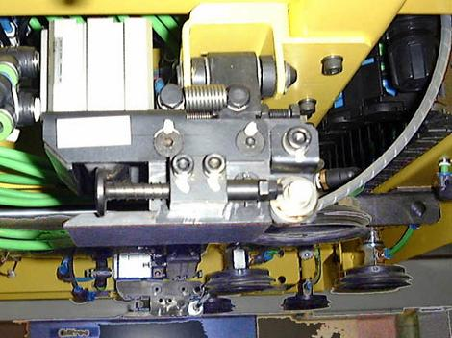
After all parts are removed from the sheet remnant or skeleton remaining, it is unloaded towards the rear of the machine. Two flip down grippers under the loader grip the right edge of the sheet and drag it off onto a ball transfer table to over the Skeleton Box. The transfer table then moves out from under the skeleton depositing it in the Skeleton Box. It is important when programming nests of part to ensure the skeleton has enough integrity to move around and be unloaded. The amount and width of framing will vary based on the material type and thickness.

System Operation

Standard Operation

Scheduling of programs is done on the turret punch press using the Intelligent Control Interface.

Blank sheets are placed on the stocker elevator and stored in advance by crane or forklift. Empty pallets must also be stored for finished parts unloading. These are loaded and unloaded at the front of the machine on the stocker elevator unit. This can also be done during system automatic operation without interrupting the punching processing.

When automatic operation starts, the stocker will retrieve the material pallet from the drawer specified in the schedule and position it at the Material Pallet position. The transfer system will then move toward the back of the system for access by the FG loader. After the material to load has been verified by the loading system, the finished parts pallet will then be retrieved from stocker and positioned at the Finished Parts Pallet position.

The loader picks up the top sheet from the Material station using air-activated vacuum pads. Magnets fan ferrous material during this operation to prevent double sheet pickup. Assistance for non-ferrous material separation will be by air blow and vacuum pad tilting/waving action.

The sheet is checked by the double sheet detector to confirm that only one blank sheet has been picked up. If this fails, multiple retries will be attempted to dislodge the multiple sheets before an alarm is generated signaling the operator.

The loader transports the sheet to the Turret Punch Press table and automatically positions it into the workholders and auto endlocator. If the sheet is not square or has not been positioned properly, multiple retries to position the sheet into the work holders and endlocator will be attempted before an alarm is generated signaling the operator

After the sheet has been positioned properly the punch press, it will close its workholders. The loader releases the sheet, retreats, and the punching operation starts.

When a nested part is finished, its edge is punched until a small tab remains. The loader unit moves in and using selected vacuum pads, grips the part. The last punch is made releasing the part from the skeleton. If the loader must reposition the vacuum pads on the part for pickup, the part is dragged over the side table between the Motorum and FG system. The loader repositions its vacuum pads on the part to fully support it. The loader unit then transports the part to the Finished Parts Pallet or the Additional Parts Tables.

When punching is finished, the remnant is positioned in toward Y=0 and to the right side of the machine. The loader unit uses flip down grippers to grip the skeleton on its edge and pull it back into the Skeleton Box.

Halting Automatic Operation

When a schedule completes, and the next job has zero sheet quantity or the arrangement (ARR) field is set to one, automatic operation will stop.

When any alarm occurs, a caution, warning, or alarm signal is generated. Many times the problem can be corrected and system operation can be restarted from where it stopped.

If all sheets on the material pallet are used, operation will continue with the next scheduled job, if available. In the schedule data, a “SKIP” field is flagged to indicate processing of that job was not completed.

If the Product Traverser becomes full in automatic operation, a caution alarm is generated, and the operator must unload the pallet.

Automatic Shutoff

The system has an automatic power shutoff feature. If activated during automatic operation, the following circumstances will cause the loader and punch press to power off.

Shutdown will occur 10 seconds after the successful completion of a scheduled job.

If an alarm, warning, or caution occurs, shutdown will occur in 30-60 seconds.

Turret Standalone Operation

When standalone operation of the punch press is required, programs can be run directly from the punch press control.

Note: Maximum material length is restricted to 144.0” (3660mm) when running the machine manually. If longer material will be run, specify maximum length requirements when ordering the loader.

Pre-Installation Requirements

The customer must meet the safety, foundation, and utility requirements according to the following notes and specifications prior to installation.

Safety

Preparation of safety guards and their installation must be reviewed and approved by the customer as per the recommended safety layout by Murata.

• Safety mats are included with the Motorum.
• Safety fencing is provided around the FG system.

Foundation

The foundation of loading/unloading devices uses anchor bolts.

The following floor specifications are required:

Soil bearing power: greater than 2.8 PSI
(2.0 metric tons/m²)
Concrete bearing power: greater than 3000 PSI
(2100 metric tons/ m²)
Thickness of concrete: greater than 5.9 in. (150mm)
Levelness of floor: within 0.787 in. (20mm)

Utilities (Electric and Pneumatic)

Electrical Power Supply:

Loading/Unloading 3 phases 200/220VAC ±10%
Devices 50/60 Hz
17 KVA

• Electric power source must be separate from that used for welding machines.

• Preparation of the Distribution Panel (including design and installation) are the customer's responsibility.

• Electric from the factory power source to the transformer of the loader is to be prepared by the customer. Murata Machinery will provide cables from the loader to the Turret Punch Press and other devices.

• Grounding resistance must be less than 100 ohm. (Cable must be separate from welding machine grounding cables.)

Pneumatic Power Supply:

Loading Device Pressure: more than 71 PSI (5.0 kgf/cm²)
Flow: more than 35.3ft³/min(1.0m³/min)
Piping: 10mm Nylon tube or 3/8" PT(male)

• Dry, clean air source is to be provided by the customer.

• Separate pneumatic piping to the primary connectors on the Motorum and the FG Loader are required.

Layout Drawing
Base system with optional extended rail and Additional Finished Parts Tables.



