

April 2021 Model AB Brake Options

Safety

Light Curtain with Footswitch
Floating blank key-switch included, some programmability. Side barriers included to completely protect throat area of machine. 1 year warranty. $6,500.00
Other brands of light curtains available at special request

Laser Guarding Systems

Wraps lasers around punch to allow operator closer to pinch-point and still be O.S.H.A. approved. 1 year warranty. $15,800.00
(Laser Guard system NOT recommended for punching/bottoming applications or applications with many die changes)

Compliance Options including UL Listing, CSA, ZED
As standard all components are U.L. listed but the system as a whole is not U.L. compliant. For U.L. compliant achine $2,500.00
NOTE! This price does not include U.L. officer sign off at destination—that is the responsibility of the customer For other listings Price per quote

Additional Footswitch and Pedestal Control $2,100.00
For multiple operators

Low Speed Retract
Ram returns in slow press speed for handling of large work pieces. $600.00

Safety Guarding for rear of press brake $5,500.00
Up to 14’. Comes with swinging gates and interlocking system for shut down while open. Custom guarding systems available.

Operational Preference Controls

Auto Return of Ram

Normal operation of ram requires operator to release footswitch to allow ram to return to upper limit. This option makes the ram return automatically even if footswitch is still depressed. $700.00

Decompression System
REQUIRED FOR BOTTOMING APPLICATIONS—allows oil pressure to bleed off to reduce shock to hydraulic system. $900.00

Lubrication System

Automatic Lubrication System (air power required)
Automatically pumps EP-1 grease through lubrication system via a timed system. Also includes flow adjustable injectors. Includes auto-shutoff with warning light when reservoir is empty. $4,700.00

Extended Warranty Service

This package includes:
⧫ A 7 year parts in lieu of standard 5 year parts warranty
⧫ A 2 year PLC and CNC warranty
⧫ A 5 year onsite limited labor warranty

100 ton through 400 ton press brake $5,200.00

Paint Color

Blue is standard on all machines—Charcoal is available at no charge but must be requested.
Special Paint Color (single color industrial enamel only)
A sample is required $700.00

Support Arms and Accessories

NOTE! All brakes come standard with (2) 24" basic work supports. T-slot support arms have precision t-slot bars added to set gravity stops.

T-Slot Support Arms
24” T-Slot Support Arm $450.00 (ea.)
36” T-slot Support Arm $800.00 (ea.)
48” T-slot Support Arm $1,000.00(ea.)
For imbedded scales in arms Add $150.00
Gravity Stop for t-slot support arm $350.00 (ea.)

5/8” T-slot across front edge of bed
Allows left to right movement of t-slot support arms INCLUDED

CNC Sheet Assist/ Follower
Heavy duty sheet follower to raise up and down with work piece controlled through 640 control (optional). Handles up to 400 lbs. $39,900.00
Parking Option $3,900.00

Quick-Release Linear Work Support System

Quick-change, quick-disconnect style support arms with heavy duty, smooth transition roller guides for easy arm movement. Multiple adjustment points on arms for super precision placement.

(2) 24” Arm System $5,900.00
(2) 36” Arm System $7,100.00
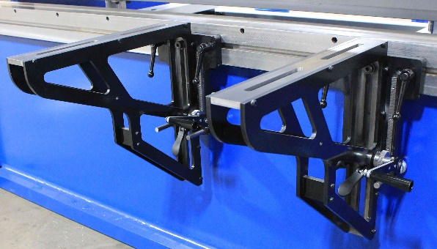

Simple Go-To Backgauge and Ram Control
NOTE! The Four Position in-line Depth Stop and the Go-To backgauge can be bought separately but they work very well together as a low cost manual X + Y axis control
Y Axis Only Ram Control

Four Position In-Line Depth Stop Mechanical Ram Control
Manual ram control that allows operator to pre-set up to 4 different ram depths/angles by adjusting mechanical limits on the side of the brake. The operator can choose from any of the 4 positions from a selector switch located on the 2 hand control pedestal out in front of machine. $2,200.00

Simple Go-To X Axis Only Backgauge
X axis 24” travel Dual drive Go-To power backgauge $13,600.00
For up to AB400-14

Simple 2-3 X Axis CNC Super basic control
NOTE! The Automec 300 control is specifically for users who want the most basic X, Y and R programming available.

Automec 300 Series Control with 24” of gauge travel
★ 300 programs
★ 11 digit part numbers  Ram depth mode + Bend Allowance
★ Teach mode  Ram Angle Mode
★ Tooling library  Gauge retract/delay
★ Auto ram reference  Onsite training for Automec control

CNC300/G24HD 2 Axis AB100-14 thru AB400-14 $22,500.00

R Axis Add $5,500.00 48” Travel Add $10,300.00

Note: Standard mechanical ram limit switches are included as back-up.

630 Control with Tooling Graphics 1-4 axis
Available up to Y + X + R + CNC CROWNING
★ Easy to use but extremely versatile control
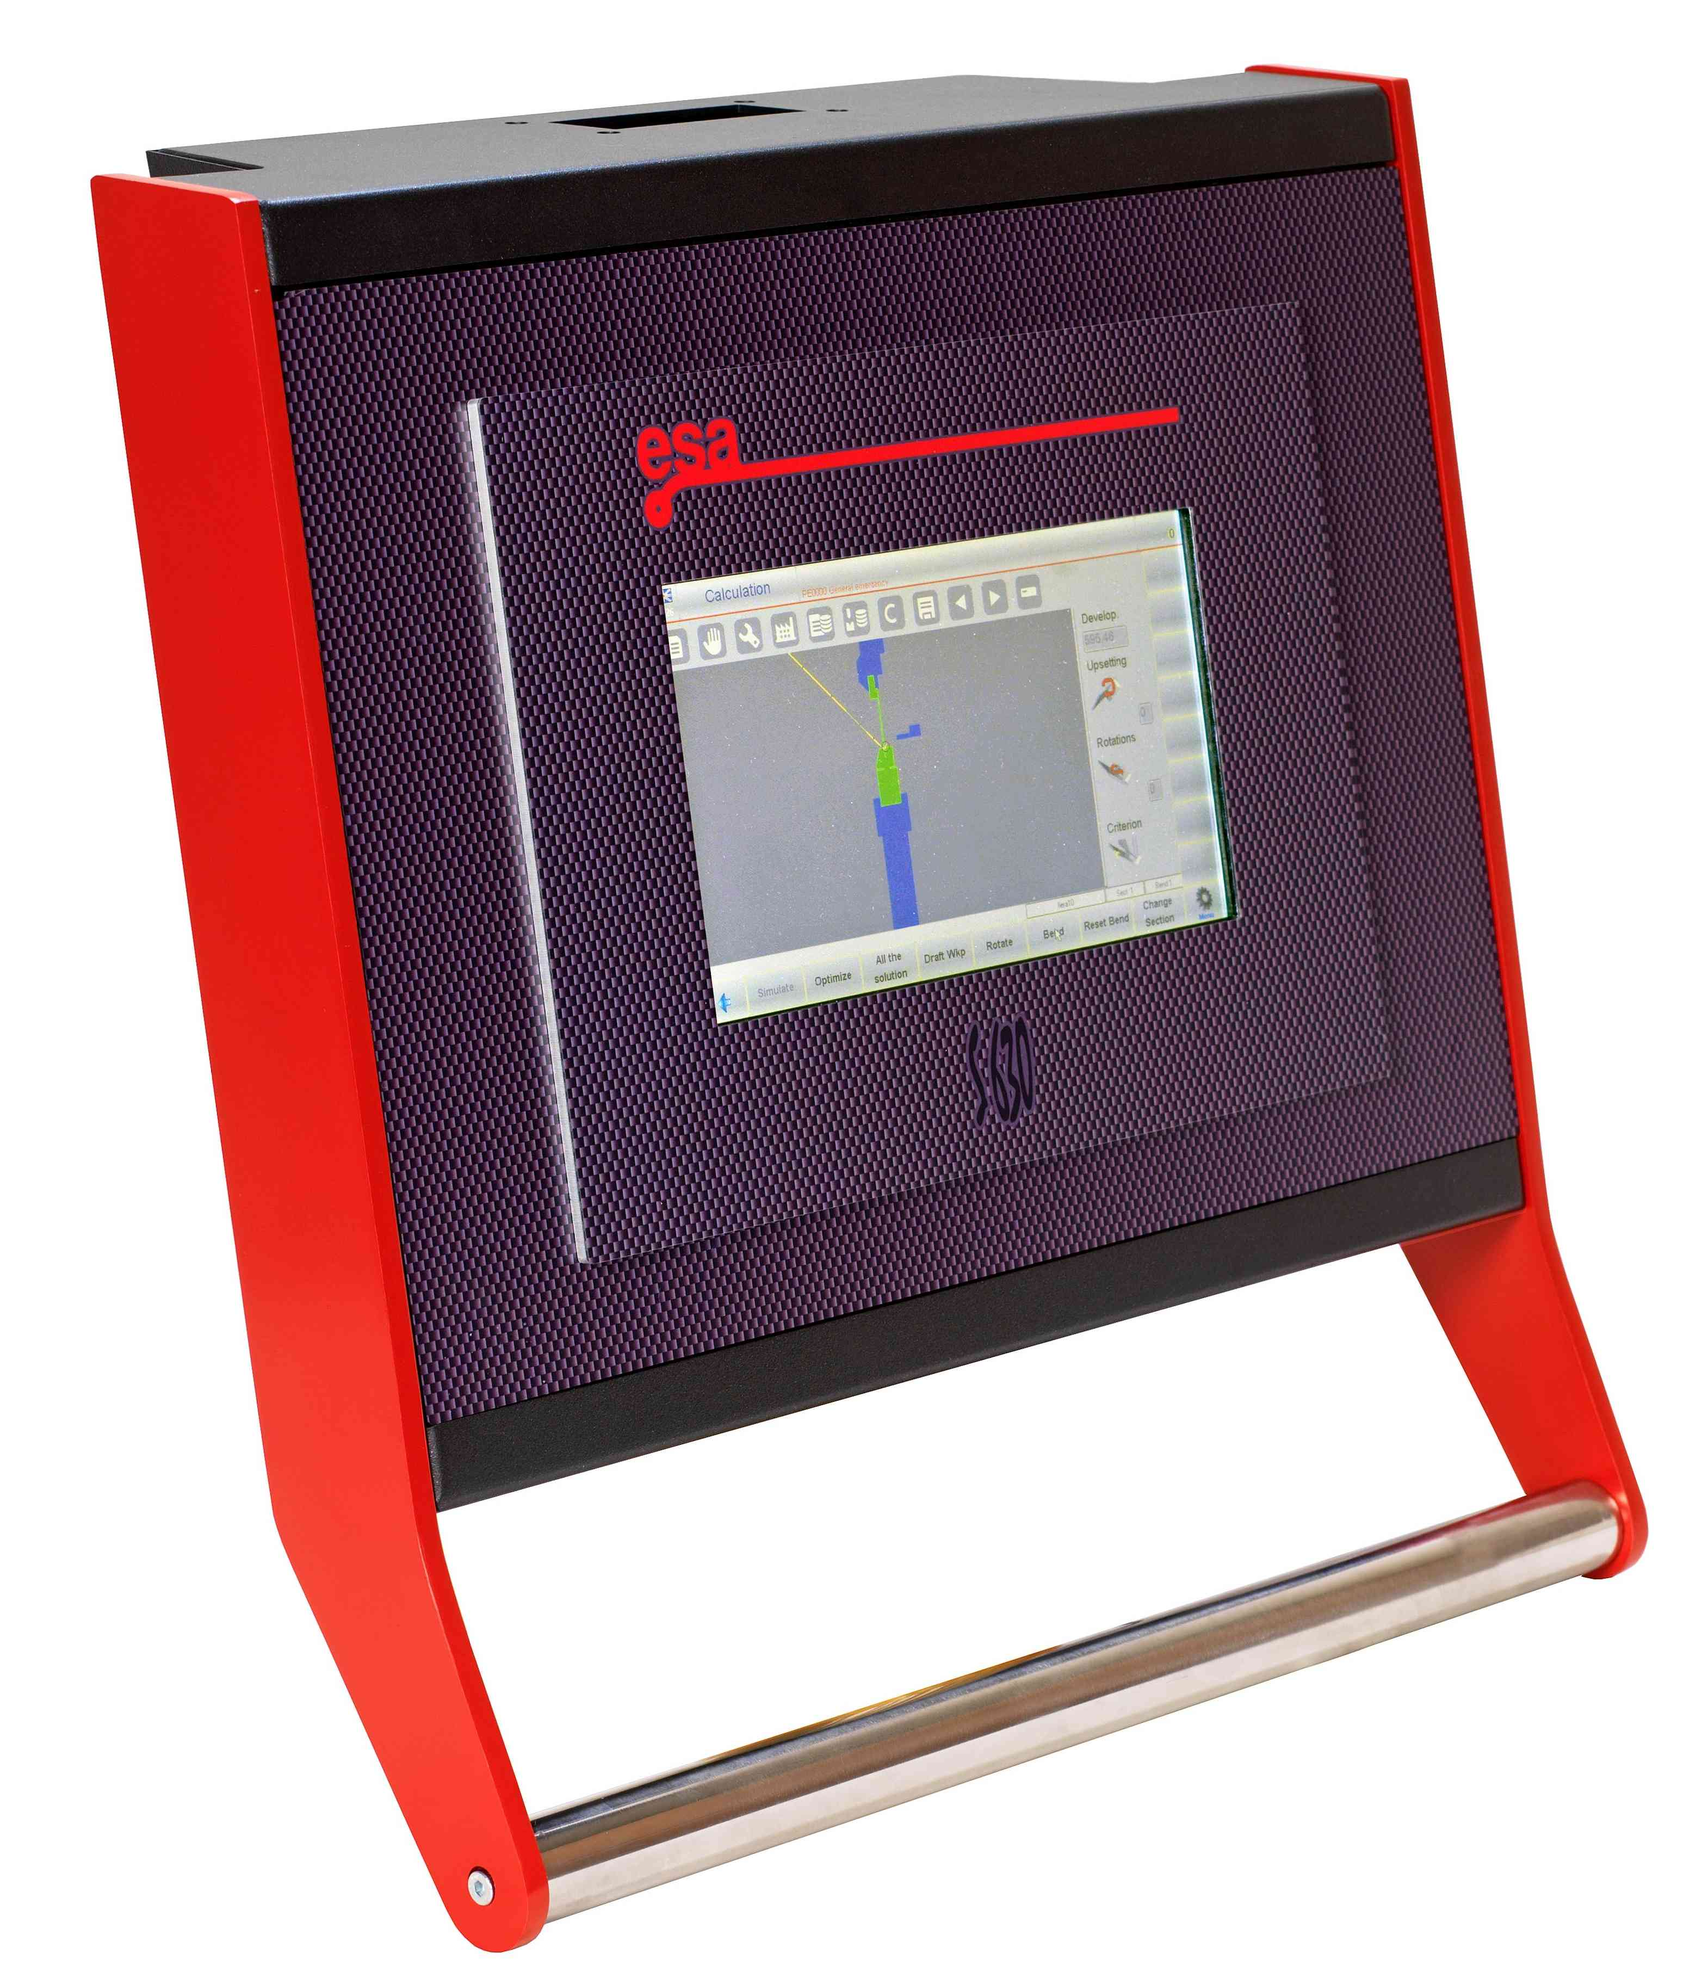
with on-screen 2D Tooling graphics
★ 10" color touchscreen mounted on pendant
★ 2D graphical Offline software for desktop
programming available optionally
★ Available with X/ Y/ R and CNC Crowning
axis programmability (crowning optional)
★ Thousands of hard drive job storage plus
unlimited job storage via USB port +
RS232 port + Ethernet
★ Extensive tooling library
★ Readily accepts most tooling files
★ Programmable delay and retract at pinch point
★ Inch/mm conversion
★ 29” of X axis gauge travel (optional 39”)
★ 8” adjustable manual R or optional power R
★ Auto return of ram included
★ Low speed retract included
★ Dwell/decompression included
★ One day onsite training in contiguous U.S.

630 w/Y axis control only (no backgauge) $9,900.00
630 X/Y axis 29” gauge travel for AB100-12/14—AB600-12/14 $24,900.00

Programmable CNC Ram tilt Allows you to program the desired ram tilt within the programmable jobs of the CNC. $3,500.00

2D Off-line programming software $900.00
R Axis Add $5,500.00
39” of gauge travel in lieu of 24” $7,900.00
Programmable tonnage $700.00
Additional finger $1,900.00
Radan 3D DXF/DWG File Transfer Capability Contact for quote

Note: mechanical ram limit switches are not included with 630 or 640 units

650 2D Graphical Control 1-6 Axis
Available up to Y + X + R + Z1-Z2 + CNC CROWNING

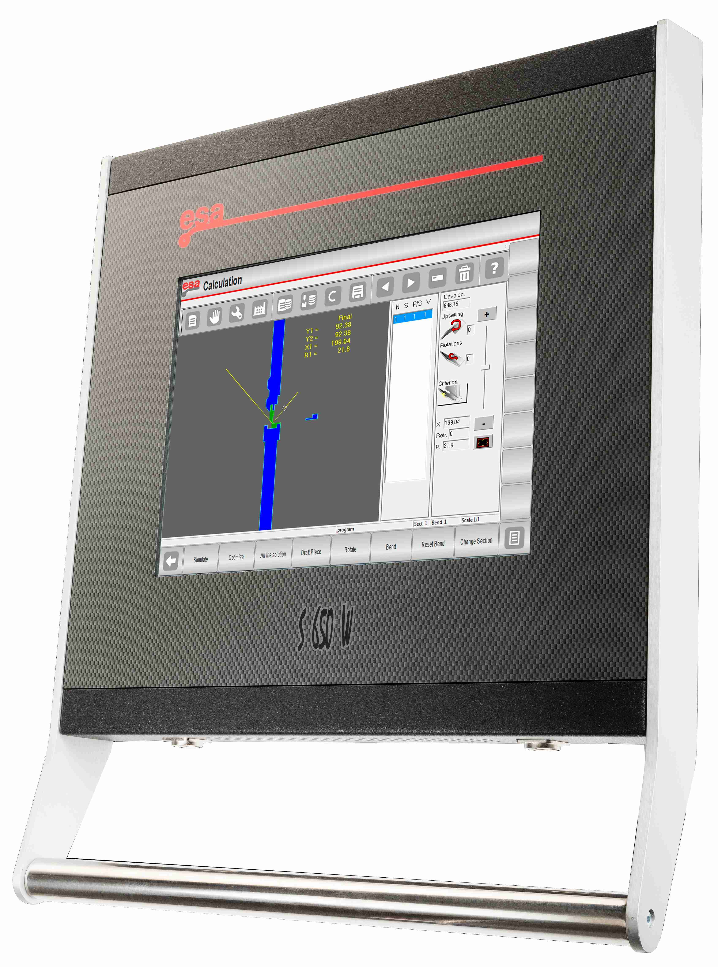
★ Remote support/service and
diagnostics via ethernet
★ Windows 10 operating system
★ Fully 2D Graphical control
w/touchscreen
★ 15” color screen on pendant
★ Crowning correction in degrees
(crowning sold separately)
★ 2D identification of best bending
sequences
★ 2D graphical Offline software for
desktop programming
★ 2D collision detection
★ Unlimited job storage via USB &
Ethernet
★ X, Y, R, Z1-Z2, X-Prime
programmability
★ Readily accepts most tooling
files
★ 30,000 hard drive programs
★ Programmable delay & retract
at pinch point
★ Direct connection of optional
Mitutoyo protractor and
Anglecheck devices to allow
process angle measurement
★ Inch/mm conversion
★ Auto return of ram included
★ Low speed retract included
★ Dwell/decompression included
★ 2 Days Onsite training at customer's facility

650 X/Y axis w/29” gauge travel for 14’ and shorter up to 600 tons $30,700.00

Programmable CNC Ram tilt Allows you to program the desired ram tilt within the programmable jobs of the CNC. $3,500.00

R Axis Add $5,500.00
Z1-Z2 Axis $9,900.00 (must have R axis)
39” of gauge travel in lieu of 24” $7,900.00
Programmable tonnage $700.00
2D graphical off-line software INCLUDED
Additional finger $1,900.00
Radan 3D DXF/DWG File Transfer Capability Contact for quote
660PC 3D CNC Control quote available upon request

Tooling

NOTE! NO DIES OR DIE HOLDERS ARE INCLUDED AS STANDARD—ALL DIES MUST BE ORDERED OPTIONALLY
NOTE: THE CUSTOMER HAS FULL RESPONSIBILITY FOR HOW WELL DIE SETS WORK FOR THEIR APPLICATIONS. PLEASE REVIEW PRESS BRAKE OPEN HEIGHT & STROKE AND TOOLING STACK HEIGHTS TO INSURE PROPER DIE PENETRATION!

Dies quoted below are subject to 1 year die manufacturer’s warranty.

FLAME HARDENING IS OPTIONAL—CONTACT FOR QUOTE

Four Way Die Sets
#225 Tooling package for 18 gauge up to 3/16” pl.
(1) 2” net height die holder
(1) 3.75” long x 1 1/8” wide, 85 degree punch with 3/64” radius
(1) 2.25” square die block with 1/2”, 3/4”, 1”, and 1 1/2” v die openings at 85 degrees.
7.5” STACK HEIGHT—note: consider die penetration

10’ in length $6,300.00
12’ in length $6,900.00
14’ in length $7,600.00

#325 Tooling package for 12 gauge up to ¼” plate
(1) 2” net height die holder
(1) 3 3/4” long x 1 1/2” wide. 85 degree punch with 3/64” radius
(1) 3 1/4” square die block with 3/4”, 1”, 1 1/2” and 2” v die openings at 85 degrees.
9” STACK HEIGHT—note: consider die penetration
10’ in length $7,500.00
12’ in length $8,500.00
14’ in length $9,400.00

#475 Tooling package for 10 gauge up to 3/8” plate
(1) 2 1/2” net height die holder
(1) 3 1/4” long x 2” wide, 85 degree punch with 1/8” radius
(1) 4 3/4” square die block with 1”, 1 1/2”, 2 1/2” and 3” wide v die openings at 85 degrees.
Total of 10.5” Stack height

12’ in length $11,100.00
14’ in length $11,900.00

#575 Tooling package for 10 gauge up to ½” plate
(1) 2 1/2”net height die holder
(1) 3 3/4” long x 1 1/2” wide, 85 degree punch with 1/8” radius
(1) 2 3/4 long x 2 1/2” wide, 85 degree punch with 1/4” radius
(1) 5.75” square die block with 1”, 2”, 3” and 5” v die openings at 85 degrees. Total of 12” Stack Height w/tall punch and 11" stack height with short punch

12’ in length $16,800.00
14’ in length $18,900.00

Die Holders/Spacers for American style tooling—Not required for 4 way die sets
3” x 3” x 10’ $2,700.00
3” x 3” x 12’ $3,000.00
3” x 3” x 14’ $3,400.00
Contact factory for other size die holders and all other tooling requirements

WILA Crowning and Clamping Systems

NOTE: Crowning is rarely needed for the AB due to the full tonnage capability the entire length of the bed but certain applications can benefit from a crowning unit. Contact the factory for more information.

Manual and CNC crowning units used for fine tuning forming applications. When using with 4 way die sets add $800.00 for clamps to hold four way die blocks from 2.25” up to 4.25”. Larger four way die sets will require E-wide or larger crowning unit.
Wila Crowning

FOR DIES UP TO 3.5” WIDE

Manual CNC Autocrown CNC Autocrown w/hyd. bed clamping

10’ $14,300.00 $17,900.00 $23,800.00
12’ $15,500.00 $19,200.00 $26,300.00
14’ $17,600.00 $21,100.00 $29,000.00

E-WIDE CROWNING FOR DIES UP TO 6” WIDE

Manual CNC Autocrown CNC Autocrown w/hyd. bed clamping

10’ $20,700.00 $24,300.00 $32,300.00
12’ $22,400.00 $26,000.00 $35,100.00
14’ $25,600.00 $29,100.00 $40,800.00

For crowning for V die openings larger than 6" contact factory
New Standard Premium, heavy duty hardened crowning systems, also available

WILA Ram Clamping Systems

Tooling for Wila quick-change ram clamping systems quoted require: American Style Tooling + Safety Tangs with all punches

Wila Hydraulic Quick-Change, Power Ram Clamping Systems

American New Standard Pro

10’ $16,500.00 $16,800.00

12’ $17,700.00 $18,200.00

14’ $19,500.00 $19,800.00
New Standard Premium, heavy duty hardened clamping systems, also available

Contact factory for quotes on all other WILA products

Removable and Non-Removable Bed and Ram Width Extensions

Machining required for Removable Flanges for up to 12’ machines
($1,600.00 each for bed or ram) $3,200.00

Removable 5”x 5” Angle flanges-- MUST INCLUDE ABOVE MACHINING

10” total additional width x 10’ long between end housings only.
For flanges longer than 10’ contact factory
($6,100.00 each for bed or ram) $12,200.00

Non-Removable Permanent Bed and Ram Flanges
Price below for 12’ overall and shorter brakes (contact factory for longer brakes)
11 ½” wide x 10’ Bed and Ram Flanges $6,400.00
(Between Housings only)
14” wide x 10’ Bed and Ram Flanges
(Between Housings only) $7,400.00
18” wide x 10’ Bed and Ram Flanges $10,600.00 (Between Housings only)
Other size Non-removable flanges are available upon request

High Speed Systems
Horsepower will increase with Hi-Speed Systems

Tonnage Standard System Hi-Speed System Price
App Press Ret App Press Ret

100/150 200 24 260 $7,900.00
200 107 20 139 183 20 236 $7,100.00
250 102 16 132 150 16 195 $7,100.00
325 90 18 116 159 18 127 $7.100.00
400 110 17 106 173 17 130 $7,600.00

For other High Speed Systems Contact Factory

Extra Open Height, Extra Throat Depth, Extra Stroke
Tonnage 12” Horn 2” Extra 4” Extra 2” Extra 2” Ex. Open Ht.
Ext. B & R Throat Throat Stroke (per every 2”)
100 $3,900.00 $3,500.00 $4,500.00 **$5,900.00 $700.00
150 $4,100.00 $3,800.00 $4,800.00 **$5,900.00 $800.00
200 $4,500.00 $3,900.00 $4,900.00 $6,500.00 $900.00
250 $4,700.00 $4,200.00 $5,200.00 $6,500.00 $900.00
325 $5,000.00 $4,800.00 $7,000.00 $7,000.00 $1,100.00
400 $5,300.00 $5,400.00 $7,400.00 $7,000.00 $1,200.00

Horn extensions provide 24” of extra bed and ram length. Longer extensions are available upon special request. Tonnage is limited on horns past the end frames to 10% of overall machine tonnage.
Consult factory for special changes not listed above. All frame changing options will be applied to new order machines only.
** NOTE: Longer Stroke NOT available on 6’, 8’ or 10’ brakes
NOTE: When ordering more than 6” of extra open height or throat depth on any tonnage consult factory for price.
NOTE: When ordering extra stroke, you do not automatically get extra open height. When ordering extra open height, you do not automatically get extra stroke. Both extra open height and extra stroke are separate options.

Start-Up / Training / Maintenance Service

NOTE! Onsite factory training/start-up is not included or required with purchase of a new press brake. Due to the simplicity of our machinery formal training is rarely required. All CNC Systems already include onsite training in quoted price.
Prior to arrival of our technician, the machine must be fully rigged in place, level, bolted down, oil in reservoir and hooked up electrically

If one day’s training/start-up for the machine is required add the following charge

Pacific/Mountain Time Zone: $3,800.00 (net)
Central Time Zone $2,800.00 (net)
Eastern Time Zone $3,400.00 (net)

Add $1,000.00 for each additional day required.

Deposit/Order Entry

A 25% NON-REFUNDABLE deposit is required at the point of order entry and the delivery schedule will not begin until the deposit is received at Standard Industrial. Customer is also required to pay for and accept delivery of machine(s) at previously agreed upon month of completion.

Voltage

If the machine is 50 H.P. or more, there will be a charge for 230, 208 or 200 volts. The standard voltage is 230-3-60 up to 40 h. p. but can be supplied up to 480-3-60 at no charge. 50 h. p. machines and above are standard with 480-3-60. Other voltages, phases and hertz are available but are subject to price increases.

Retro-Fit NOTE:

All Prices listed in these options pages are available with the purchase of a new press brake AT THE POINT OF ORDER ENTRY. After orders have been placed, any added or changed options will be subject to retro-fit prices.
If ordering options for retro-fit in the field, many of these options are subject to crating charges for safe shipping purposes. Large items like backgauges will have crating charges as well as additional charges to ease the retro-fitting process.

NOTE: No tooling, gauging or oil is included as standard with the purchase of a new press brake. Tooling is available optionally. Customer will need to supply Mobil DTE24 or equivalent hydraulic oil (contact factory for amount).

WARRANTY STATEMENT

The main frame and ram are warranted for structural integrity (cracks in the welds) for Five years. The drive components such as shafts, bearings and slides are warranted for Five years, and purchased hydraulic and electric components (not PLC) for Five years. Any PLC or PLC related items or CNC options have a 2 year warranty. Tooling and tooling related items are subject to the manufacturer’s warranty, typically 1 year.
Limited onsite labor is included as part of the 5 year warranty but it is ONLY included as part of the warranty with express written consent of manufacturer after all troubleshooting has been fulfilled by customer.
All Prices Are Subject To change At Any Time. Customer is responsible for freight, rigging, leveling and electrical hook-up unless otherwise agreed upon.
Terms: 25% deposit required at the point of order to begin delivery schedule or hold quick delivery machine. All Prices are fob Clarksdale, MS and are in U.S. dollars.
The customer is responsible for all applicable local, state and federal taxes and tariffs. Customer is required to take delivery of and pay for machine at agreed upon time of completion.
Standard Industrial is only responsible for the operation of the machine itself and specifically not responsible for the customer’s application. Standard will not be held responsible if the machine does not perform to the customer’s expectations due to the customer’s assumption that Standard is familiar with their application. This includes all dies and die related items, CNC, PLC, supports, peripherals, options and add-ons of any kind.

All pricing is subject to change at any time

DELIVERY SCHEDULE—subject to change

Quotation Date and Quote Number:

Prices are F.O.B. Clarksdale, MS

Current Delivery Starts at Receipt of 25% Non-Refundable Deposit:

